Software Engineering
Professor: Hoh Peter In

Exam II Sample Questions

NAME: _____________________________ Student ID#: ___________________

Chapter 5

- (a) What is UML? How can it help your class project?
- Explain the following diagram (what it is, why important, how to draw)
  - Use case diagram
  - Sequence diagram
  - Class diagram
  - State diagram

- Draw sequence diagram and class diagram bsed on the following requirements

“A receptionist may transfer data from the Mentcase system to a general patient record database that is maintained by a health authority. The information transferred may either be updated personal information (address, phone number, etc.) or a summary of the patient’s diagnosis and treatment.”

- Textbook Exercises 5.4 ~ 5.8

Chapter 6.
- (a) What is Software Architecture?
(b) Why is Software Architecture important?
(c) What are invariants of the following Software Architectures Patterns? (see Ch. 6.3)
- Layered architecture
- Repository architecture
- Client-server architecture
- Pipe-filter architecture
(d) Apply the above architecture patterns into your class project and compare its pros and cons. Select one and justify why you choose it.

4. Textbook Exercise 6.4 ~ 6.6

Chapter 7.

- (a) What is Design patterns?
(b) Why is Design patterns important?
(c) Explain Design patterns with an example (e.g., Observer pattern)
(d) Show how to apply Design patterns for your class project. What are their benefits and issues to do so?

- (a) What is open-source development?
(b) What is the pros and cons to apply open-source development for your class project?
(c) What are the potential risks (or issues) to apply open-source development for your class project?

- Textbook Exercises 7.3, 7.6 ~ 7.8

Chapter 8.

- (a) What are Validation and Verification?
(b) Explain the development testing approaches
- Unit testing
- Component testing
- System testing

- Suggest 8 test cases for binary search routine (see below) based on equivalence partitions. The test cases should be composed of Input Array (T), Key (Key), and Output (Found, L). The following explanation would be helpful. Please assume that INPUT array (T) has a range of the following values: 1000 to 2000.

Structure testing is an approach to testing where the tests are derived from knowledge of the software’s structure and implementation. Structural testing is usually applied to relatively small program units such as subroutines or the operations associated with an object. As the name implies, the tester can analyze the code and use knowledge about the structure of a component to derive test data. The analysis of the code can be used to find how many test cases are needed to guarantee that all of the statements in the program or component are executed at least once during the testing process. Figure 20.9 is a binary search routine. A pre-condition is to use an ordered array, that the value of the lower bound of the array must be less than the value of the upper bound. By examining the code of the search routine, we can see that binary searching involves splitting the search space into three parts. Each of these parts makes up an equivalence partition. Test cases where the key lies at the boundaries of each of these partitions should be chosen to exercise the code.
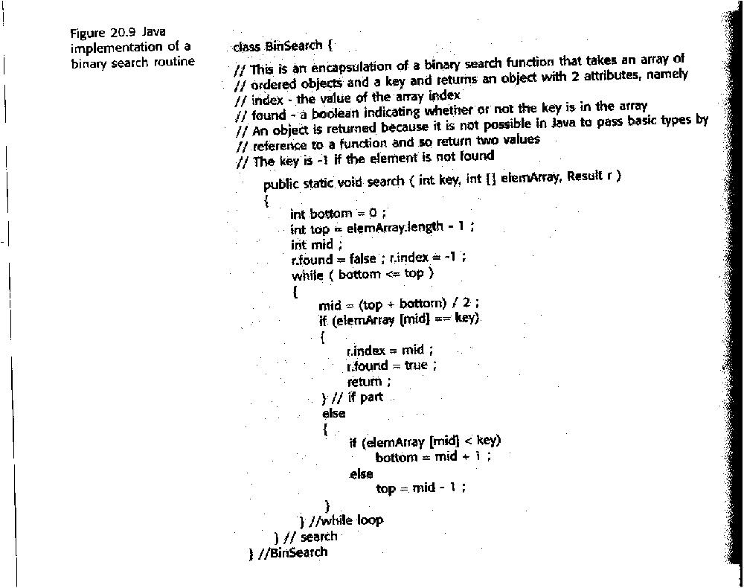

- The following diagram is the flow graph for the binary search procedure. Please provide four independent paths through the binary search flow graphs. And calculate the cyclomatic complexity of the search flow graphs.

Note: If all of these paths (of the flow graphs) are executed we can be sure that:
1. every statement in the method has been executed at least once, and
2. every branch has been exercised for true and false conditions.

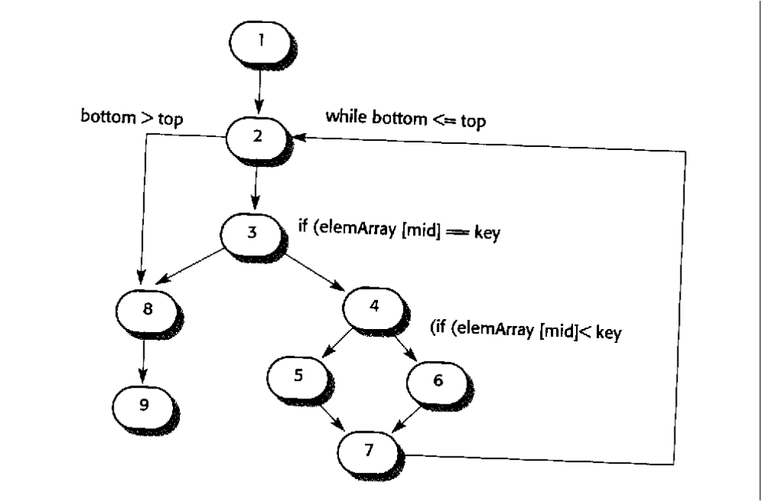
10
11

Chapter 9.

- Textbook Exercises 9.4, 9.5 ~9.10

Chapter 16 ~ 17.

- Draw a component diagram of your project with interfaces (the most high level of the whole system)
An example is shown below.

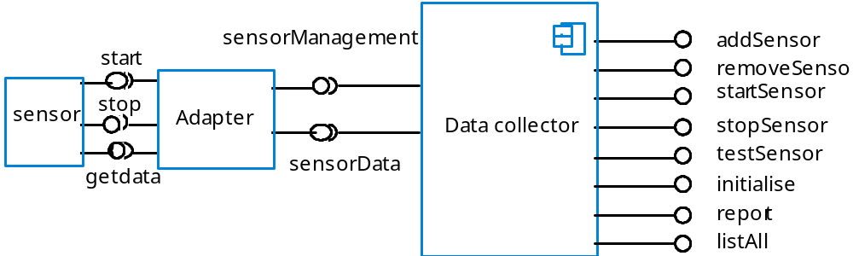

- (a) If a “program” is defined as a set of web browsing to achieve a certain service/goal instead of a set of instructions (i.e., make web browsing componentization), you may identify new issues of component-based software engineering. Please list at least three new issues.

(b) The following diagram defines interactions among web components for a travel reservation. Each web component is based on existing web service. For example, airline reservation web component helps reserve airline using existing web services of airline companies. Through these interactions, conference, airline, rental car, and hotel can be automatically reserved. Please discuss at least three challenges in designing or/and implementing these interactions. Explain each challenge with a simple example.

conference
Reservation
Airline
Reservation
Rental car
Reservation
Hotel
Reservation
Component (C)
Interaction
conference
Reservation
Airline
Reservation
Rental car
Reservation
Hotel
Reservation
Component (C)
Interaction

- Textbook Exercises 16.1, 16.5, 16.8, 16.9, 17.6, 17.7

Chapter 22 ~ 25.

- Textbook Exercises 22.1, 22.2, 22.4~6, 22.9

- (a) List at least top 5 risks of your class project and make a mitigation plan of each risk.
(b) How to motivate your team members in your class project?

- (a) Draw an activity network based on the following table of task durations and dependencies. Note that the starting date is 1/1/02 (MM/DD/YY). Assume that every day is working day including Saturday and Sunday. (14 pts)

Task | Duration (calendar days) | Dependencies
T1 | 7
T2 | 14
T3 | 14 | T1 (M1)
T6 | 7 | T1, T2 (M3)

(b) List the critical path in the activity network that you drew above

- Textbook Exercises 23.2 ~ 23.6

- Textbook Exercises 24.1 ~ 24.3, 24.6, 24.8

- Textbook Exercises 25.1 ~ 25.5, 25.9

